PALM SUNDAY April 13, 2025
Prairieland Parish
As we unite in worship today, we extend a warm welcome to each one present. May we together experience the presence of God
+++++++++++++++++++++++++++++++++++++++++++++++++.
We Gather to Prepare Our Hearts to Meet Our Lord

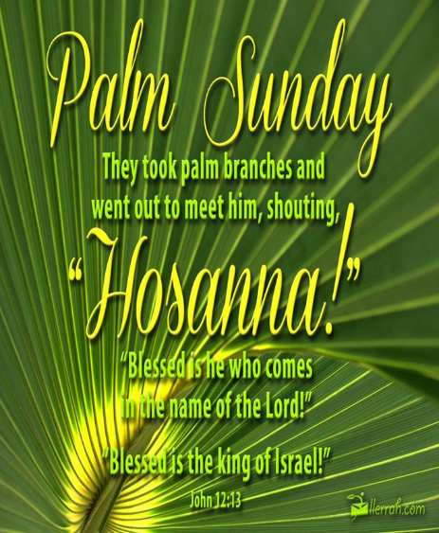

Prelude - Welcome - Announcements

The story of Jesus’ entry into Jerusalem, tells us that after his celebrated arrival.
He went into the Temple and looked around at everything.

As we gather here for worship today may it be with a sense that Jesus
has walked in too and is looking around.

May our eyes be open to see Him, may our hearts be ready to be seen by Him,
may our worship be worthy of His presence, and may we be transformed
so that we see the world through His eyes. Amen.

A CALL TO WORSHIP FOR PALM SUNDAY
Open the gates and let him in!
As we love to give thanks to our Lord.
Clear a path and call on his name.
As we shout our praises to our Lord!
Wave your palms and welcome him.
As our home is forever your home, our Lord.
Lay you palms at his feet for each step he takes.
As we bless the holy land you walk on, our Lord.
Shout your wishes and pray for relief!
As we know you will gift our faith, our Lord.
Stand tall, with your heads held high.
As we breathe in the presence of grace, our Lord.
Raise your voices and sound your horns!
As we live to play, in your name, our Lord.
Bow your heads and clasp your hands.
As we will always exalt you, our Lord.
Give thanks to him.
For you are good, our Lord.
Love him.
You are the only one, our Lord!

OPENING PRAYER
Almighty God, on this day your Son Jesus Christ entered the holy city of Jerusalem and was proclaimed King by those who spread their garments and palm branches along his way. Let those branches be for us signs of his victory, and grant that we who bear them in his name may ever hail him as our Lord and follow him in the way that leads to eternal life. In his name we pray. Amen.

Praise Hymn #278 Hosanna, Loud Hosanna
Author: Jeanette Threlfall (1873)
Publication Date: 1989
Tune Information
Name: ELLACOMBE
Adapter and Harmonizer: W. H. Monk (1868)
Source: Gesangbuch der H. W. k. Hofkapelle, 1784

1. Hosanna, loud hosanna,
the little children sang;
through pillared court and temple
the lovely anthem rang.
To Jesus, who had blessed them
close folded to his breast,
the children sang their praises,
the simplest and the best.

2. From Olivet they followed
mid an exultant crowd,
the victor palm branch waving,
and chanting clear and loud.
The Lord of earth and heaven
rode on in lowly state,
nor scorned that little children
should on his bidding wait.

3. "Hosanna in the highest!"
that ancient song we sing,
for Christ is our Redeemer,
the Lord of heaven our King.
O may we ever praise him
with heart and life and voice,
and in his blissful presence
eternally rejoice!

We Hear God’s Word
Gospel Reading…………………………………………………...… Luke 19:28-40
New Revised Standard Version

Jesus’ Triumphal Entry into Jerusalem
28 After he had said this, he went on ahead, going up to Jerusalem.

29 When he had come near Bethphage and Bethany, at the place called the Mount of Olives, he sent two of the disciples, 30 saying, “Go into the village ahead of you, and as you enter it you will find tied there a colt that has never been ridden. Untie it and bring it here. 31 If anyone asks you, ‘Why are you untying it?’ just say this, ‘The Lord needs it.’” 32 So those who were sent departed and found it as he had told them. 33 As they were untying the colt, its owners asked them, “Why are you untying the colt?” 34 They said, “The Lord needs it.” 35 Then they brought it to Jesus; and after throwing their cloaks on the colt, they set Jesus on it. 36 As he rode along, people kept spreading their cloaks on the road. 37 As he was now approaching the path down from the Mount of Olives, the whole multitude of the disciples began to praise God joyfully with a loud voice for all the deeds of power that they had seen, 38 saying,

“Blessed is the king
who comes in the name of the Lord!
Peace in heaven,
and glory in the highest heaven!”

39 Some of the Pharisees in the crowd said to him, “Teacher, order your disciples to stop.” 40 He answered, “I tell you, if these were silent, the stones would shout out.”

The word of God for the People of God, Thanks Be to God

Children’s Message
Faith Hymn #2085 He Came Down
Arranger: John Bell
Copyright: © 1990 WGRG The Iona Community (Scotland). Used by permission of GIA Publications, Inc.

1 He came down that we may have love;
he came down that we may have love;
he came down that we may have love;
Hallelujah forevermore.

2 He came down that we may have peace;
he came down that we may have peace;
he came down that we may have peace;
Hallelujah forevermore.

3 He came down that we may have joy;
he came down that we may have joy;
he came down that we may have joy;
Hallelujah forevermor
*Meditation*
Joys/Concerns

Prayers of the People for Palm Sunday
Together we come to God, aware of our brokenness, aware of our call, aware of the world’s need, and asking that we be strengthened for ministry.
God who comes in church, remind your people that you are larger than our experience, larger than this congregation, larger than Sunday morning. Free us from the constraints we try to place on our religious lives
God who comes in politics, Jesus made a very public statement by his ride into Jerusalem. In the face of the world’s cynicism, in the face of our own mis-trust, keep us open to sharing your love.
God who comes in the unexpected, you surprise us by coming to us from outside, from people who are strangers, in times and places where we do not look for you. Keep us receptive to being amazed
God who comes in illness, you promise healing. Free us from demanding the shape which that healing takes. As we pray for those who need our prayers, especially [NAMES, AND] those we name before you, open us to your presence in all our circumstances.
God who comes in all, you are not limited to our expectations. Break through our usual ways of thinking, our familiar ways of seeing, our comfortable ways of being. Shatter our normal, and come to bring us life
We offer all these prayers, as well as the unspoken longings of our hearts, to you, liberating God, in the name of Jesus, your liberating Savior who taught us to pray:

Offertory/Doxology/Prayer
Triumphant God, we echo the shouts of “Hosanna!” as we relive the entry of Jesus into Jerusalem and all that waits in the week to come. Like that first parade so long ago, we may have different ideas of what kind of a messiah we long to welcome. Many of us seek one who thinks like we think, who will wield power to meet our longings. As we give our gifts this morning, may we be of the heart and mind of submission. You know better than us the messiah that is needed for your kingdom to come on earth, as it is in heaven. In Christ, we pray. Amen. (Luke 19:28-40 & Luke 22:14-23:56)

Departing Hymn #277 “Tell Me the Stories of Jesus”
Author: | William H. Parker (1885)
Publication Date: | 1989

1. Tell me the stories of Jesus I love to hear;
things I would ask him to tell me if he were here:
scenes by the wayside, tales of the sea,
stories of Jesus, tell them to me.
2. First let me hear how the children stood round his knee,
and I shall fancy his blessing resting on me;
words full of kindness, deeds full of grace,
all in the lovelight of Jesus' face.
3. Into the city I'd follow the children's band,
waving a branch of the palm tree high in my hand;
one of his heralds, yes, I would sing
loudest hosannas, "Jesus is King!"

*Holy Week Benediction*
And now, my friends go forth. To a week where transformation
Will meet you and guide you. Do not hide when they recognize you,
Do not doubt when you see Christ, Do not deny when you are confronted.
Do not stop until you are at the cross, and there you will see the light;
And the burdens of your heart will roll away. Until then, God be with you!
Amen

Postlude

